CE100 Algorithms and Programming II

Matrix Multiplication / Quick Sort

Author: Asst. Prof. Dr. Uğur CORUH

## CE100 Algorithms and Programming II

## Week-3 (Matrix Multiplication/ Quick Sort)

#### Spring Semester, 2021-2022

Download [DOC-PDF](ce100-week-3-matrix.en.md_doc.pdf), [DOC-DOCX](ce100-week-3-matrix.en.md_word.docx), [SLIDE](ce100-week-3-matrix.en.md_slide.pdf), [PPTX](ce100-week-3-matrix.en.md_slide.pptx)

## Matrix Multiplication / Quick Sort

## Outline (1)

* Matrix Multiplication
  + Traditional
  + Recursive
  + Strassen

## Outline (2)

* Quicksort
  + Hoare Partitioning
  + Lomuto Partitioning
  + Recursive Sorting

## Outline (3)

* Quicksort Analysis
  + Randomized Quicksort
  + Randomized Selection
    - Recursive
    - Medians

## Matrix Multiplication (1)

* **Input: $A=\left[a_{ij}\right],B=\left[b_{ij}\right]$**
* **Output: $C=\left[c_{ij}\right]=A⋅B$ $⇒i,j=1,2,3,…,n$**

$$\left[\begin{matrix}c_{11} & c_{12} & … & c_{1n} \\ c_{21} & c_{22} & … & c_{2n} \\ ⋮ & ⋮ & ⋮ & ⋱ \\ c_{n1} & c_{n2} & … & c_{nn}\end{matrix}\right]=\left[\begin{matrix}a_{11} & a_{12} & … & a_{1n} \\ a_{21} & a_{22} & … & a_{2n} \\ ⋮ & ⋮ & ⋮ & ⋱ \\ a_{n1} & a_{n2} & … & a_{nn}\end{matrix}\right]⋅\left[\begin{matrix}b_{11} & b_{12} & … & b_{1n} \\ b_{21} & b_{22} & … & b_{2n} \\ ⋮ & ⋮ & ⋮ & ⋱ \\ b_{n1} & a_{n2} & … & b_{nn}\end{matrix}\right]$$

## Matrix Multiplication (2)

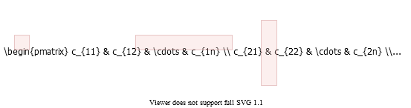

alt:“alt” height:450px center



## Matrix Multiplication: Standard Algorithm

Running Time: $Θ\left(n^{3}\right)$

for i=1 to n do  
 for j=1 to n do  
 C[i,j] = 0  
 for k=1 to n do  
 C[i,j] = C[i,j] + A[i,k] + B[k,j]  
 endfor  
 endfor  
endfor

## Matrix Multiplication: Divide & Conquer (1)

**IDEA:** Divide the $nxn$ matrix into $2x2$ matrix of $\left(n/2\right)x\left(n/2\right)$ submatrices.

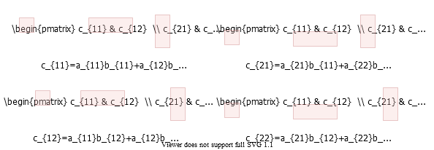

alt:“alt” height:450px center

## Matrix Multiplication: Divide & Conquer (2)

$$\left[\begin{matrix}c_{11} & c_{12} \\ c_{21} & c_{22}\end{matrix}\right]=\left[\begin{matrix}a_{11} & a_{12} \\ a_{21} & a_{22}\end{matrix}\right]⋅\left[\begin{matrix}b_{11} & b_{12} \\ b_{21} & b_{22}\end{matrix}\right]$$

$$\text{8 mults and 4 adds of (n/2)*(n/2) submatrices}=\left\{\begin{matrix}c_{11}=a_{11}b_{11}+a_{12}b_{21} \\ c_{21}=a_{21}b_{11}+a_{22}b_{21} \\ c_{12}=a_{11}b_{12}+a_{12}b_{22} \\ c_{22}=a_{21}b_{12}+a_{22}b_{22}\end{matrix}\right.$$

## Matrix Multiplication: Divide & Conquer (3)

MATRIX-MULTIPLY(A, B)  
 // Assuming that both A and B are nxn matrices  
 if n == 1 then   
 return A * B  
 else   
 //partition A, B, and C as shown before  
 C[1,1] = MATRIX-MULTIPLY (A[1,1], B[1,1]) +   
 MATRIX-MULTIPLY (A[1,2], B[2,1]);   
  
 C[1,2] = MATRIX-MULTIPLY (A[1,1], B[1,2]) +   
 MATRIX-MULTIPLY (A[1,2], B[2,2]);   
  
 C[2,1] = MATRIX-MULTIPLY (A[2,1], B[1,1]) +   
 MATRIX-MULTIPLY (A[2,2], B[2,1]);  
  
 C[2,2] = MATRIX-MULTIPLY (A[2,1], B[1,2]) +   
 MATRIX-MULTIPLY (A[2,2], B[2,2]);  
 endif   
  
 return C

## Matrix Multiplication: Divide & Conquer Analysis

$T\left(n\right)=8T\left(n/2\right)+Θ\left(n^{2}\right)$

* $8$ recursive calls $⇒8T\left(⋯\right)$
* each problem has size $n/2$ $⇒⋯T\left(n/2\right)$
* Submatrix addition $⇒Θ\left(n^{2}\right)$

## Matrix Multiplication: Solving the Recurrence

* + ,
* Case 1: $\frac{n^{log_{b}^{a}}}{f\left(n\right)}=Ω\left(n^{ε}\right)⇒T\left(n\right)=Θ\left(n^{log_{b}^{a}}\right)$

Similar with ordinary (iterative) algorithm.

## Matrix Multiplication: Strassen’s Idea (1)

Compute $c_{11},c_{12},c_{21},c_{22}$ using $7$ recursive multiplications.

In normal case we need $8$ as below.

$$\left[\begin{matrix}c_{11} & c_{12} \\ c_{21} & c_{22}\end{matrix}\right]=\left[\begin{matrix}a_{11} & a_{12} \\ a_{21} & a_{22}\end{matrix}\right]⋅\left[\begin{matrix}b_{11} & b_{12} \\ b_{21} & b_{22}\end{matrix}\right]$$

$$\text{8 mults and 4 adds of (n/2)*(n/2) submatrices}=\left\{\begin{matrix}c_{11}=a_{11}b_{11}+a_{12}b_{21} \\ c_{21}=a_{21}b_{11}+a_{22}b_{21} \\ c_{12}=a_{11}b_{12}+a_{12}b_{22} \\ c_{22}=a_{21}b_{12}+a_{22}b_{22}\end{matrix}\right.$$

## Matrix Multiplication: Strassen’s Idea (2)

* **Reminder:**
  + Each submatrix is of size $\left(n/2\right)*\left(n/2\right)$
  + Each add/sub operation takes $Θ\left(n^{2}\right)$ time
* Compute $P1…P7$ using $7$ recursive calls to matrix-multiply

$$\begin{matrix}P_{1} & =a_{11}*\left(b_{12}−b_{22}\right) \\ P_{2} & =\left(a_{11}+a_{12}\right)*b_{22} \\ P_{3} & =\left(a_{21}+a_{22}\right)*b_{11} \\ P_{4} & =a_{22}*\left(b_{21}−b_{11}\right) \\ P_{5} & =\left(a_{11}+a_{22}\right)*\left(b_{11}+b_{22}\right) \\ P_{6} & =\left(a_{12}−a_{22}\right)*\left(b_{21}+b_{22}\right) \\ P_{7} & =\left(a_{11}−a_{21}\right)*\left(b_{11}+b_{12}\right)\end{matrix}$$

## Matrix Multiplication: Strassen’s Idea (3)

$$\begin{matrix}P_{1} & =a_{11}*\left(b_{12}−b_{22}\right) \\ P_{2} & =\left(a_{11}+a_{12}\right)*b_{22} \\ P_{3} & =\left(a_{21}+a_{22}\right)*b_{11} \\ P_{4} & =a_{22}*\left(b_{21}−b_{11}\right) \\ P_{5} & =\left(a_{11}+a_{22}\right)*\left(b_{11}+b_{22}\right) \\ P_{6} & =\left(a_{12}−a_{22}\right)*\left(b_{21}+b_{22}\right) \\ P_{7} & =\left(a_{11}−a_{21}\right)*\left(b_{11}+b_{12}\right)\end{matrix}$$

* How to compute $c_{ij}$ using $P1…P7$?

$$\begin{matrix}c_{11} & =P_{5}+P_{4}–P_{2}+P_{6} \\ c_{12} & =P_{1}+P_{2} \\ c_{21} & =P_{3}+P_{4} \\ c_{22} & =P_{5}+P_{1}–P_{3}–P_{7}\end{matrix}$$

## Matrix Multiplication: Strassen’s Idea (4)

* $7$ recursive multiply calls
* $18$ add/sub operations

## Matrix Multiplication: Strassen’s Idea (5)

e.g. Show that $c_{12}=P_{1}+P_{2}$:

$$\begin{matrix}c_{12} & =P_{1}+P_{2} \\ & =a_{11}\left(b_{12}–b_{22}\right)+\left(a_{11}+a_{12}\right)b_{22} \\ & =a_{11}b_{12}−a_{11}b_{22}+a_{11}b_{22}+a_{12}b_{22} \\ & =a_{11}b_{12}+a_{12}b_{22}\end{matrix}$$

## Strassen’s Algorithm

* **Divide:** Partition $A$ and $B$ into $\left(n/2\right)*\left(n/2\right)$ submatrices. Form terms to be multiplied using $+$ and $−$.
* **Conquer:** Perform $7$ multiplications of $\left(n/2\right)*\left(n/2\right)$ submatrices recursively.
* **Combine:** Form $C$ using $+$ and $–$ on $\left(n/2\right)*\left(n/2\right)$ submatrices.

**Recurrence: $T\left(n\right)=7T\left(n/2\right)+Θ\left(n^{2}\right)$**

## Strassen’s Algorithm: Solving the Recurrence (1)

* + ,
* Case 1: $\frac{n^{log_{b}^{a}}}{f\left(n\right)}=Ω\left(n^{ε}\right)⇒T\left(n\right)=Θ\left(n^{log_{b}^{a}}\right)$

$T\left(n\right)=Θ\left(n^{log_{2}^{7}}\right)$

$2^{3}=8,2^{2}=4$ so $⇒log_{2}^{7}≈2.81$

or use https://www.omnicalculator.com/math/log

## Strassen’s Algorithm: Solving the Recurrence (2)

* The number $2.81$ may not seem much smaller than $3$
* But, it is significant because the difference is in the exponent.
* Strassen’s algorithm beats the ordinary algorithm on today’s machines for $n≥30$ or so.
* Best to date: $Θ\left(n^{2.376…}\right)$ (of theoretical interest only)

## Matrix Multiplication Solution Faster Than Strassen’s Algorithm

* In 5 Oct. 2022 new paper published
  + [Discovering faster matrix multiplication algorithms with reinforcement learning | Nature](https://www.nature.com/articles/s41586-022-05172-4)
  + [GitHub - deepmind/alphatensor](https://github.com/deepmind/alphatensor)
  + [Article](files/s41586-022-05172-4.pdf)
  + [Discovering novel algorithms with AlphaTensor](https://www.deepmind.com/blog/discovering-novel-algorithms-with-alphatensor)

## Matrix Multiplication Solution Faster Than Strassen’s Algorithm

For example, if the traditional algorithm taught in school multiplies a 4x5 by 5x5 matrix using 100 multiplications, and this number was reduced to 80 with human ingenuity, AlphaTensor has found algorithms that do the same operation using just 76 multiplications.

## Matrix Multiplication Solution Faster Than Strassen’s Algorithm

[center h:450px]

## Standard Multiplication

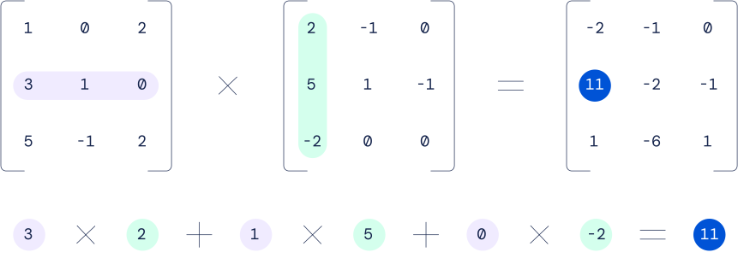

center h:400px

## Standard and Strassen Comparison

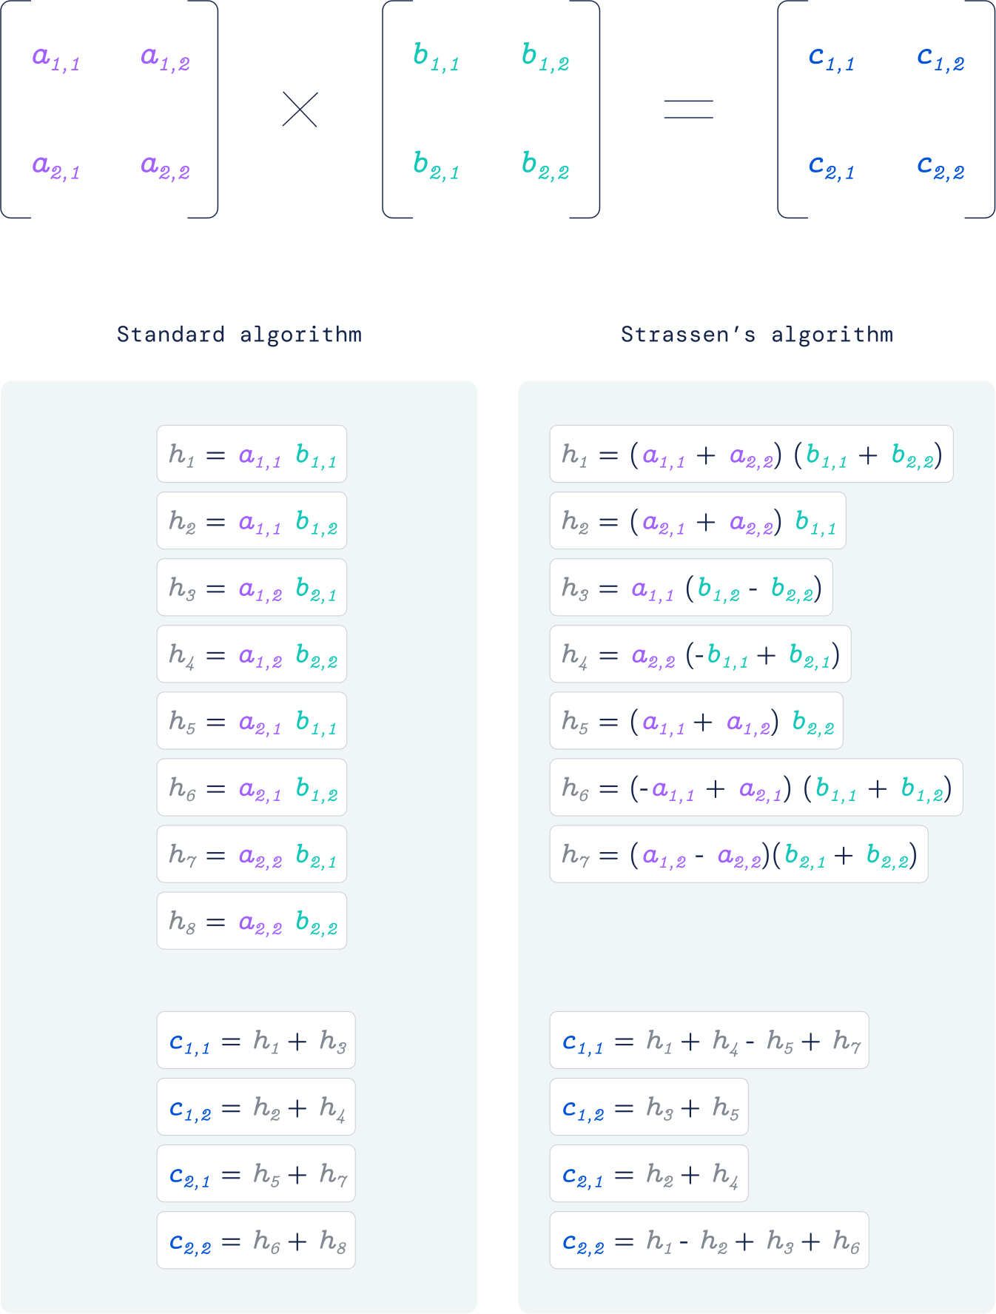

bg right h:650px

## Improved Solution

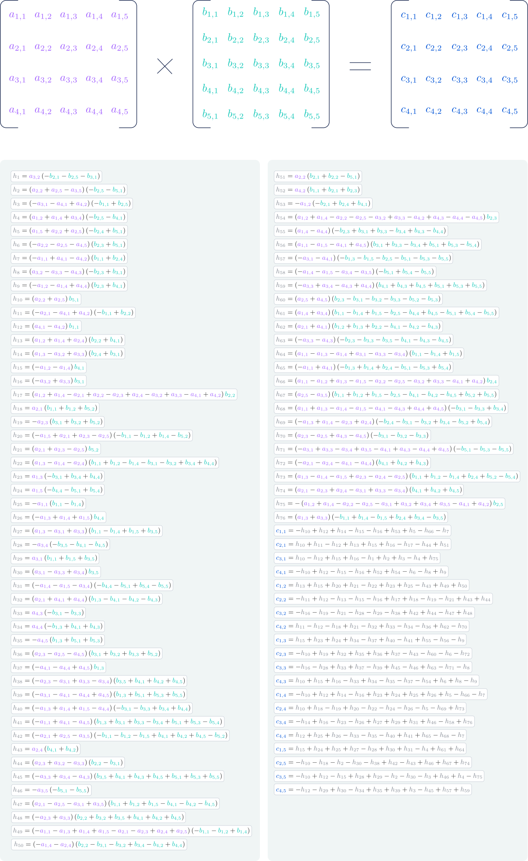

bg right h:660px

## How it’s done

“Single-player game played by AlphaTensor, where the goal is to find a correct matrix multiplication algorithm. The state of the game is a cubic array of numbers (shown as grey for 0, blue for 1, and green for -1), representing the remaining work to be done.”

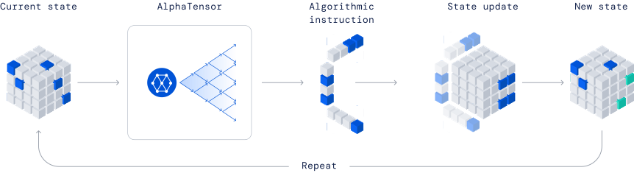

center h:350px

## Maximum Subarray Problem

**Input:** An array of values

**Output:** The contiguous subarray that has the largest sum of elements

* Input array: $\left[13\right]\left[−3\right]\left[−25\right]\left[20\right]\left[−3\right]\left[−16\right]\left[−23\right]\overset{\text{max. contiguous subarray}}{\overbrace{\left[18\right]\left[20\right]\left[−7\right]\left[12\right]}}\left[−22\right]\left[−4\right]\left[7\right]$

## Maximum Subarray Problem: Divide & Conquer (1)

* **Basic idea:**
  + **Divide** the input array into 2 from the middle
  + Pick the **best** solution among the following:
    - The max subarray of the **left half**
    - The max subarray of the **right half**
    - The max subarray **crossing the mid-point**

## Maximum Subarray Problem: Divide & Conquer (2)

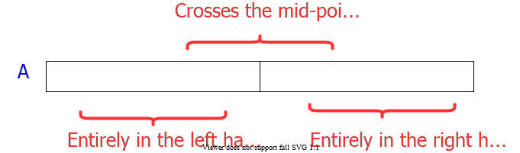

alt:“alt” height:450px center

## Maximum Subarray Problem: Divide & Conquer (3)

* **Divide:** Trivial (divide the array from the middle)
* **Conquer:** Recursively compute the max subarrays of the left and right halves
* **Combine:** Compute the max-subarray crossing the $mid−point$
  + (can be done in $Θ\left(n\right)$ time).
  + Return the max among the following:
    - the max subarray of the $\text{left-subarray}$
    - the max subarray of the $\text{rightsubarray}$
    - the max subarray crossing the $\text{mid-point}$

TODO : detailed solution in textbook…

## Conclusion : Divide & Conquer

* Divide and conquer is just one of several powerful techniques for algorithm design.
* Divide-and-conquer algorithms can be analyzed using recurrences and the master method (so practice this math).
* Can lead to more efficient algorithms

## Quicksort (1)

* One of the most-used algorithms in practice
* Proposed by **C.A.R.** *Hoare* in 1962.
* Divide-and-conquer algorithm
* In-place algorithm
  + The additional space needed is O(1)
  + The sorted array is returned in the input array
  + *Reminder: Insertion-sort is also an in-place algorithm, but Merge-Sort is not in-place.*
* Very practical

## Quicksort (2)

* **Divide:** Partition the array into 2 subarrays such that elements in the lower part $≤$ elements in the higher part
* **Conquer:** Recursively sort 2 subarrays
* **Combine:** Trivial (because in-place)

**Key:** Linear-time $\left(Θ\left(n\right)\right)$ partitioning algorithm

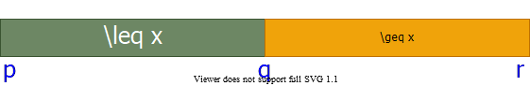

alt:“alt” height:200px center

## Divide: Partition the array around a pivot element

* Choose a pivot element $x$
* Rearrange the array such that:
  + Left subarray: All elements $≤x$
  + Right subarray: All elements $≥x$
* 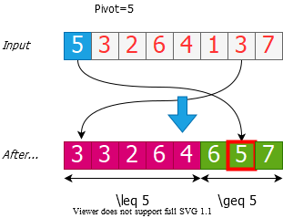
* alt:“alt” height:350px center

## Conquer: Recursively Sort the Subarrays

Note: Everything in the left subarray ≤ everything in the right subarray

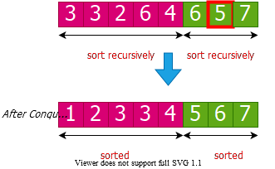

alt:“alt” height:350px center

Note: Combine is trivial after conquer. Array already sorted.

## Two partitioning algorithms

* **Hoare’s algorithm:** Partitions around the first element of subarray

$\left(pivot=x=A\left[p\right]\right)$

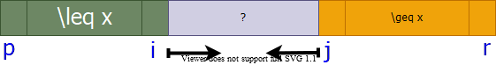

alt:“alt” height:100px center

* **Lomuto’s algorithm:** Partitions around the last element of subarray

$\left(pivot=x=A\left[r\right]\right)$

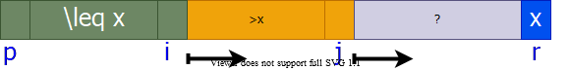

alt:“alt” height:100px center

## Hoare’s Partitioning Algorithm (1)

* Choose a pivot element: $pivot=x=A\left[p\right]$



alt:“alt” height:100px center

* Grow two regions:
  + from left to right: $A\left[p…i\right]$
  + from right to left: $A\left[j…r\right]$
    - such that:
  + every element in $A\left[p…i\right]≤$ pivot
  + every element in $A\left[p…i\right]≥$ pivot

## Hoare’s Partitioning Algorithm (2)

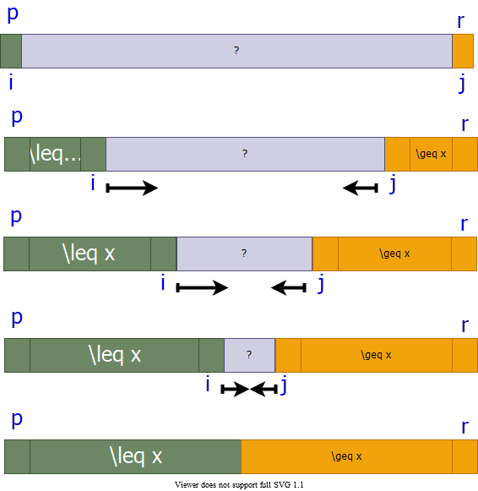

alt:“alt” height:550px center

## Hoare’s Partitioning Algorithm (3)

* Elements are exchanged when
  + $A\left[i\right]$ is **too large** to belong to the **left** region
  + $A\left[j\right]$ is **too small** to belong to the **right** region
    - assuming that the inequality is strict
* The two regions $A\left[p…i\right]$ and $A\left[j…r\right]$ grow until $A\left[i\right]≥pivot≥A\left[j\right]$

H-PARTITION(A, p, r)  
 pivot = A[p]  
 i = p - 1  
 j = r - 1  
 while true do  
 repeat j = j - 1 until A[j] <= pivot  
 repeat i = i - 1 until A[i] <= pivot  
 if i < j then   
 exchange A[i] with A[j]  
 else   
 return j

## Hoare’s Partitioning Algorithm Example (Step-1)

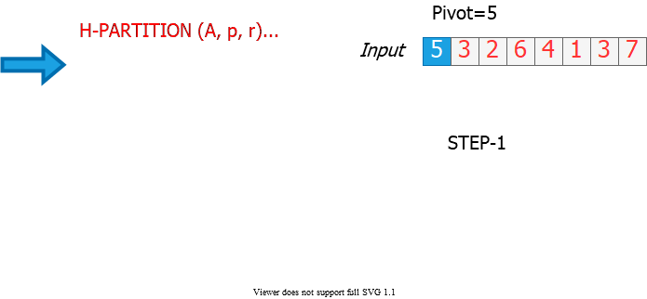

alt:“alt” height:500px center

## Hoare’s Partitioning Algorithm Example (Step-2)

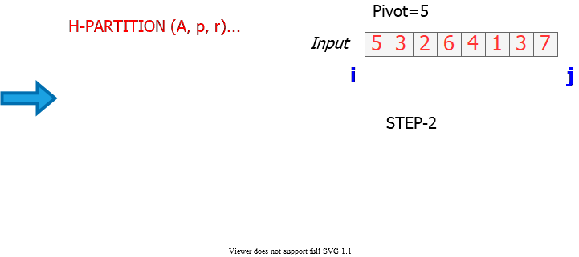

alt:“alt” height:500px center

## Hoare’s Partitioning Algorithm Example (Step-3)

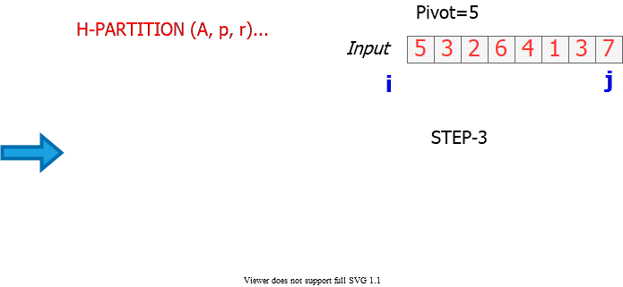

alt:“alt” height:500px center

## Hoare’s Partitioning Algorithm Example (Step-4)

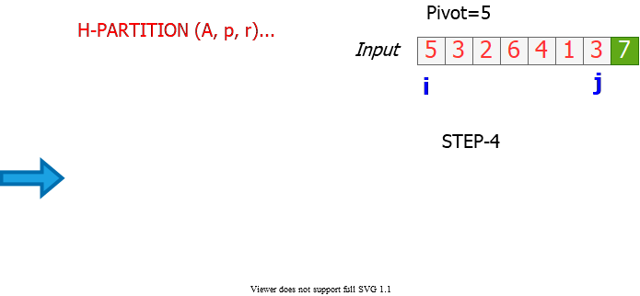

alt:“alt” height:500px center

## Hoare’s Partitioning Algorithm Example (Step-5)

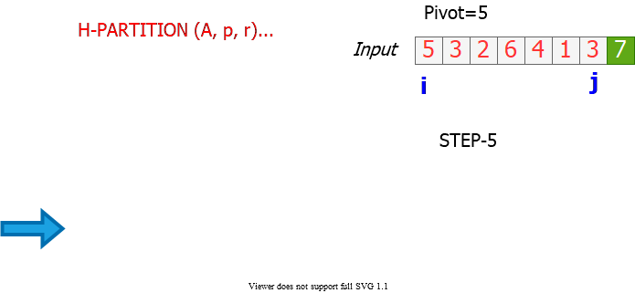

alt:“alt” height:500px center

## Hoare’s Partitioning Algorithm Example (Step-6)

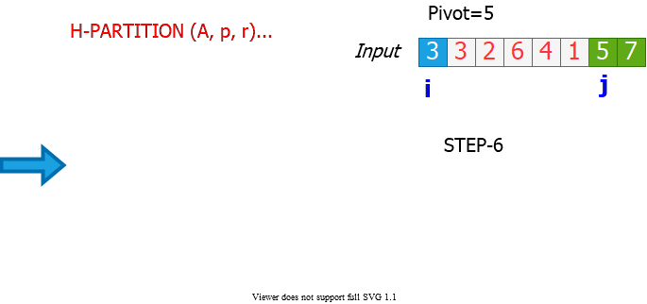

alt:“alt” height:500px center

## Hoare’s Partitioning Algorithm Example (Step-7)

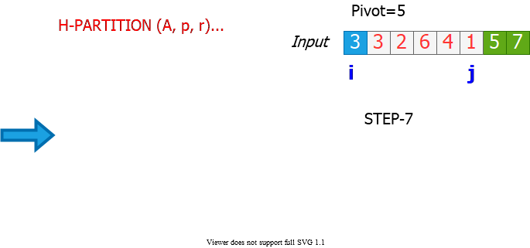

alt:“alt” height:550px center

## Hoare’s Partitioning Algorithm Example (Step-8)

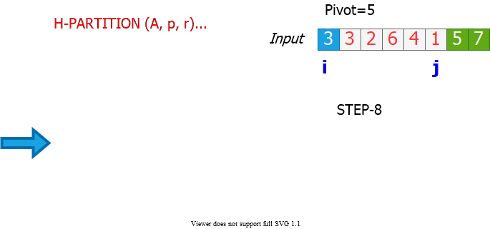

alt:“alt” height:500px center

## Hoare’s Partitioning Algorithm Example (Step-9)

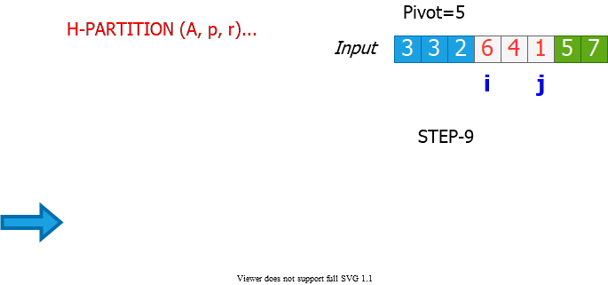

alt:“alt” height:500px center

## Hoare’s Partitioning Algorithm Example (Step-10)

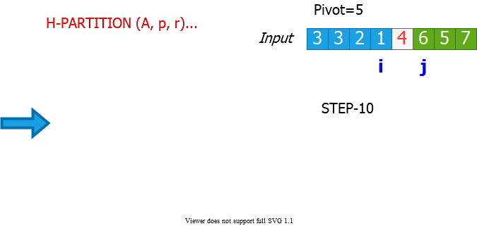

alt:“alt” height:500px center

## Hoare’s Partitioning Algorithm Example (Step-11)

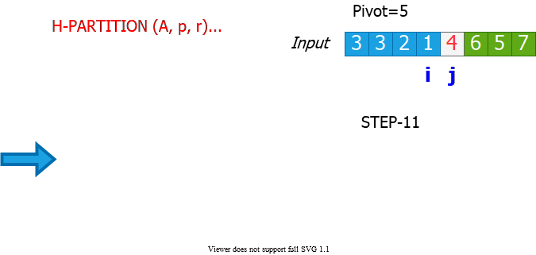

alt:“alt” height:500px center

## Hoare’s Partitioning Algorithm Example (Step-12)

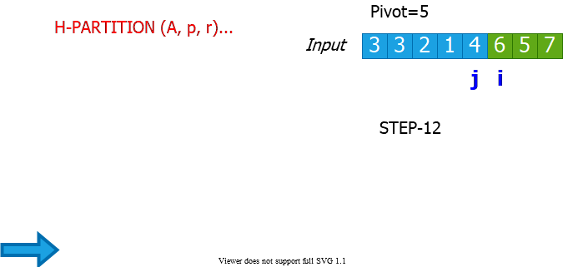

alt:“alt” height:500px center

## Hoare’s Partitioning Algorithm - Notes

* Elements are exchanged when
  + $A\left[i\right]$ is **too large** to belong to the **left** region
  + $A\left[j\right]$ is **too small** to belong to the **right** region
    - assuming that the inequality is strict
* The two regions $A\left[p…i\right]$ and $A\left[j…r\right]$ grow until $A\left[i\right]≥pivot≥A\left[j\right]$
* The asymptotic runtime of Hoare’s partitioning algorithm $Θ\left(n\right)$

H-PARTITION(A, p, r)  
 pivot = A[p]  
 i = p - 1  
 j = r - 1  
 while true do  
 repeat j = j - 1 until A[j] <= pivot  
 repeat i = i - 1 until A[i] <= pivot  
 if i < j then exchange A[i] with A[j]  
 else return j

## Quicksort with Hoare’s Partitioning Algorithm

QUICKSORT (A, p, r)  
 if p < r then  
 q = H-PARTITION(A, p, r)  
 QUICKSORT(A, p, q)  
 QUICKSORT(A, q + 1, r)  
 endif

Initial invocation: QUICKSORT(A,1,n)



alt:“alt” height:150px center

## Hoare’s Partitioning Algorithm: Pivot Selection

* if we select pivot to be $A\left[r\right]$ instead of $A\left[p\right]$ in **H-PARTITION**



alt:“alt” height:90px center

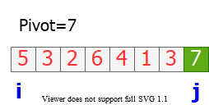

alt:“alt” height:140px center

* Consider the example where $A\left[r\right]$ is the largest element in the array:
  + End of H-PARTITION: $i=j=r$
  + In QUICKSORT: $q=r$
    - So, recursive call to:
      * QUICKSORT(A, p, q=r)
        + **infinite loop**

## Correctness of Hoare’s Algorithm (1)

We need to prove $3$ claims to show correctness:

* Indices $i$ and $j$ never reference $A$ outside the interval $A\left[p…r\right]$
* Split is always non-trivial; i.e., $j≠r$ at termination
* Every element in $A\left[p…j\right]≤$ every element in $A\left[j+1…r\right]$ at termination



alt:“alt” height:150px center

## Correctness of Hoare’s Algorithm (2)

* Notations:
  + $k$: $\#$ of times the while-loop iterates until termination
  + $i_{m}$: the value of index i at the end of iteration $m$
  + $j_{m}$: the value of index j at the end of iteration $m$
  + $x$: the value of the pivot element
* **Note**: We always have $i_{1}=p$ and $p≤j_{1}≤r$ because $x=A\left[p\right]$

## Correctness of Hoare’s Algorithm (3)

**Lemma 1:** Either $i_{k}=j_{k}$ or $i_{k}=j_{k}+1$ at termination

**Proof of Lemma 1:**

* The algorithm terminates when $i≥j$ (the else condition).
* So, it is sufficient to prove that $i_{k}–j_{k}≤1$
* There are $2$ cases to consider:
  + Case 1: $k=1$, i.e. the algorithm terminates in a single iteration
  + Case 2: $k>1$, i.e. the alg. does not terminate in a single iter.
* **By contradiction**, assume there is a run with $i_{k}–j_{k}>1$

## Correctness of Hoare’s Algorithm (4)

**Original correctness claims:**

* Indices $i$ and $j$ never reference A outside the interval $A\left[p…r\right]$
* Split is always non-trivial; i.e., $j≠r$ at termination

**Proof:**

* **For $k=1$:**
  + Trivial because $i_{1}=j_{1}=p$ (*see Case 1 in proof of Lemma 2*)
* **For $k>1$:**
  + $i_{k}>p$ and $j_{k}<r$ (*due to the repeat-until loops moving indices*)
  + $i_{k}≤r$ and $j_{k}≥p$ (*due to Lemma 1 and the statement above*)

**The proof of claims (a) and (b) complete**

## Correctness of Hoare’s Algorithm (5)

**Lemma 2:** At the end of iteration $m$, where $m<k$ (*i.e. m is not the last iteration*), we must have: $A\left[p…i_{m}\right]≤x$ and $A\left[j_{m}…r\right]≥x$

**Proof of Lemma 2:**

* **Base case: $m=1$** and $k>1$ (*i.e. the alg. does not terminate in the first iter.*)

**Ind. Hyp.:** At the end of iteration $m−1$, where $m<k$ (*i.e. m is not the last iteration*), we must have: $A\left[p…i_{m}−1\right]≤x$ and $A\left[j_{m}−1…r\right]≥x$

**General case:** The lemma holds for $m$, where $m<k$

**Proof of base case complete!**

## Correctness of Hoare’s Algorithm (6)

**Original correctness claim:**

* 1. Every element in $A\left[…j\right]≤$ every element in $A\left[j+…r\right]$ at termination

**Proof of claim (c)**

* There are $3$ cases to consider:
  + **Case 1: $k=1$** , i.e. the algorithm terminates in a single iteration
  + **Case 2: $k>1$** and $i_{k}=j_{k}$
  + **Case 3: $k>1$** and $i_{k}=j_{k}+1$

## Lomuto’s Partitioning Algorithm (1)

* Choose a pivot element: $pivot=x=A\left[r\right]$



alt:“alt” height:100px center

* Grow two regions:
  + from left to right: $A\left[p…i\right]$
  + from left to right: $A\left[i+1…j\right]$
    - such that:
      * every element in $A\left[p…i\right]≤pivot$
      * every element in $A\left[i+1…j\right]>pivot$

## Lomuto’s Partitioning Algorithm (2)

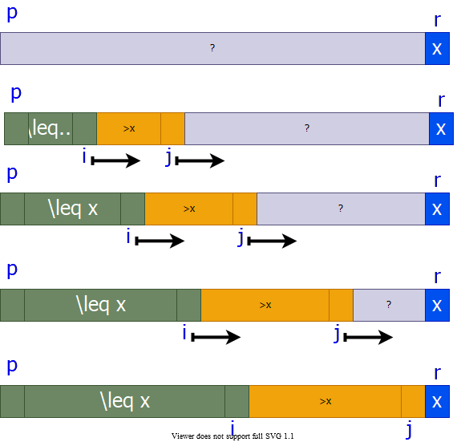

alt:“alt” height:500px center

## Lomuto’s Partitioning Algorithm Ex. (Step-1)

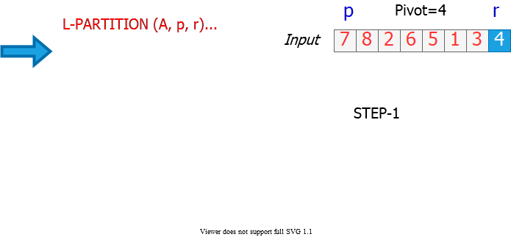

alt:“alt” height:500px center

## Lomuto’s Partitioning Algorithm Ex. (Step-2)

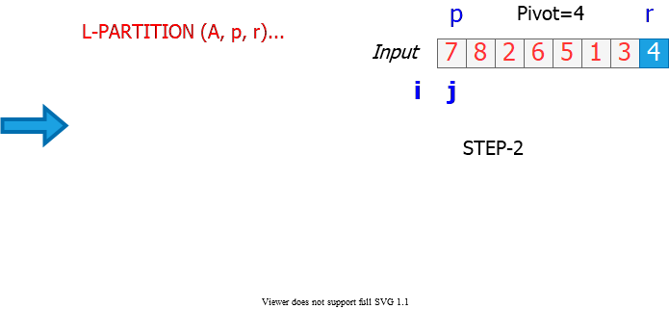

alt:“alt” height:500px center

## Lomuto’s Partitioning Algorithm Ex. (Step-3)

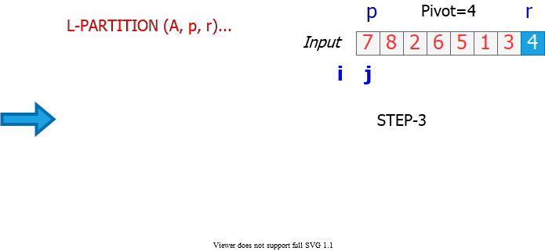

alt:“alt” height:500px center

## Lomuto’s Partitioning Algorithm Ex. (Step-4)

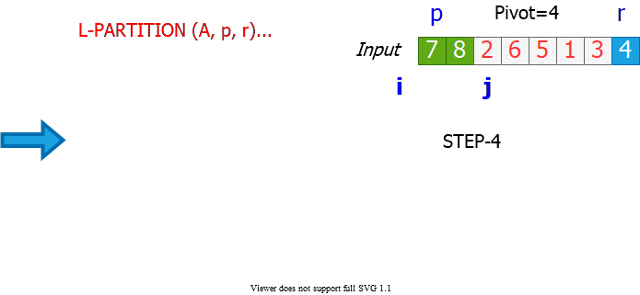

alt:“alt” height:500px center

## Lomuto’s Partitioning Algorithm Ex. (Step-5)

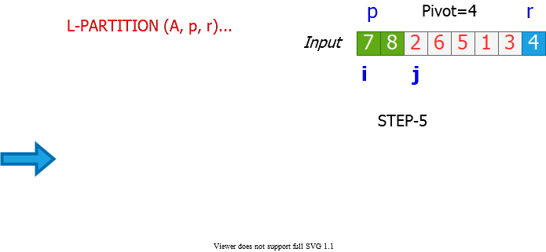

alt:“alt” height:500px center

## Lomuto’s Partitioning Algorithm Ex. (Step-6)

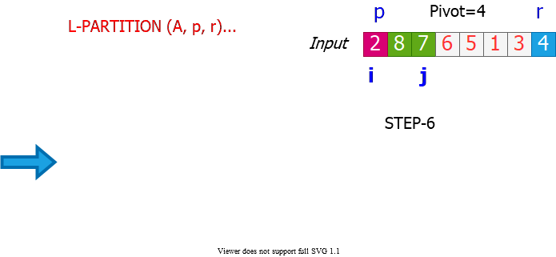

alt:“alt” height:500px center

## Lomuto’s Partitioning Algorithm Ex. (Step-7)

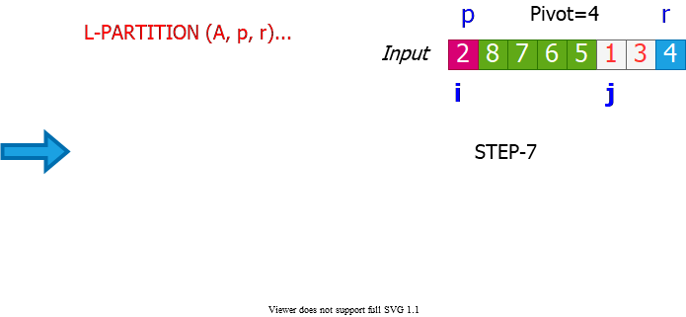

alt:“alt” height:550px center

## Lomuto’s Partitioning Algorithm Ex. (Step-8)

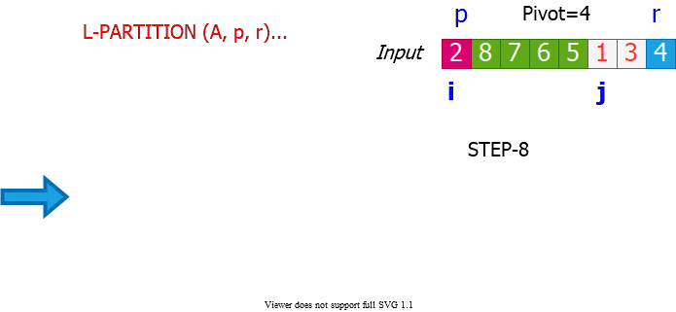

alt:“alt” height:500px center

## Lomuto’s Partitioning Algorithm Ex. (Step-9)

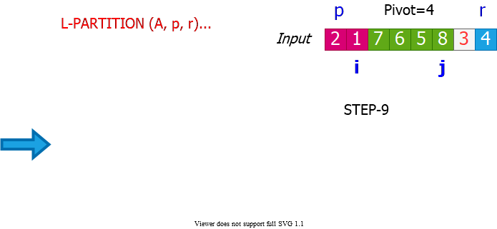

alt:“alt” height:500px center

## Lomuto’s Partitioning Algorithm Ex. (Step-10)

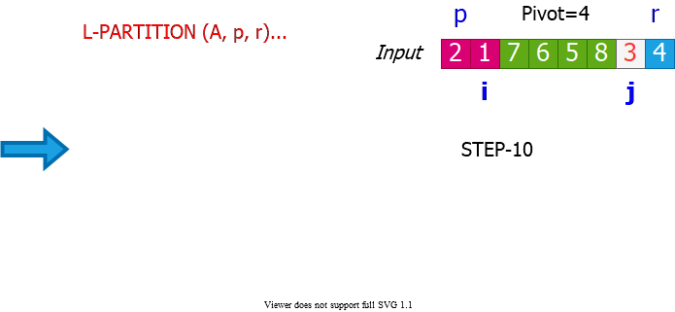

alt:“alt” height:500px center

## Lomuto’s Partitioning Algorithm Ex. (Step-11)

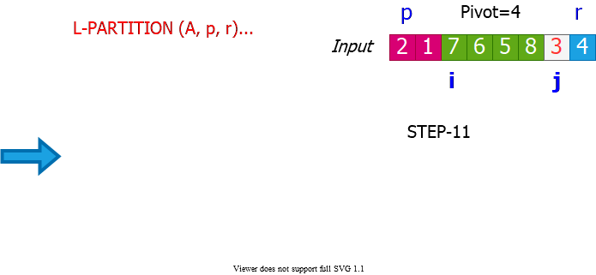

alt:“alt” height:500px center

## Lomuto’s Partitioning Algorithm Ex. (Step-12)

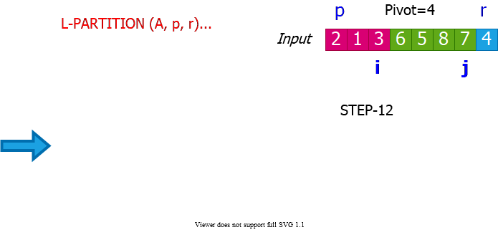

alt:“alt” height:500px center

## Lomuto’s Partitioning Algorithm Ex. (Step-13)

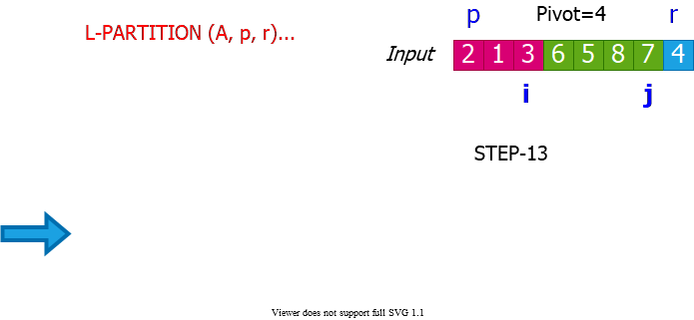

alt:“alt” height:500px center

## Lomuto’s Partitioning Algorithm Ex. (Step-14)

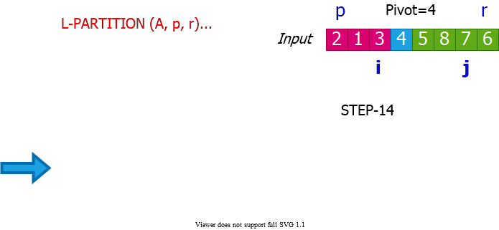

alt:“alt” height:500px center

## Lomuto’s Partitioning Algorithm Ex. (Step-15)

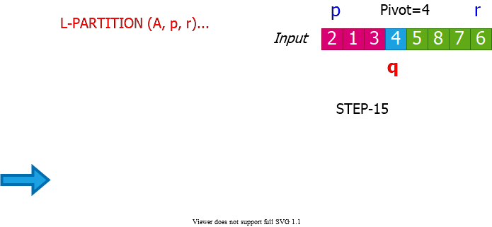

alt:“alt” height:500px center

## Quicksort with Lomuto’s Partitioning Algorithm

QUICKSORT (A, p, r)  
 if p < r then  
 q = L-PARTITION(A, p, r)  
 QUICKSORT(A, p, q - 1)  
 QUICKSORT(A, q + 1, r)  
 endif

Initial invocation: QUICKSORT(A,1,n)

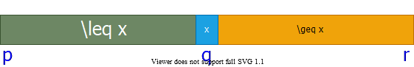

alt:“alt” height:150px center

## Comparison of Hoare’s & Lomuto’s Algorithms (1)

* Notation: $n=r−p+1$
  + $pivot=A\left[p\right]$ (*Hoare*)
  + $pivot=A\left[r\right]$ (*Lomuto*)
* $\#$**of element exchanges: $e\left(n\right)$** 
  + Hoare: $0≥e\left(n\right)≥⌊\frac{n}{2}⌋$
    - **Best**: $k=1$ with $i_{1}=j_{1}=p$ (i.e., $A\left[p+1…r\right]>pivot$)
    - **Worst**: $A\left[p+1…p+⌊\frac{n}{2}⌋−1\right]≥pivot≥A\left[p+⌈\frac{n}{2}⌉…r\right]$
  + Lomuto : $1≤e\left(n\right)≤n$
    - **Best**: $A\left[p…r−1\right]>pivot$
    - **Worst**: $A\left[p…r−1\right]≤pivot$

## Comparison of Hoare’s & Lomuto’s Algorithms (2)

* $\#$**of element comparisons: $c_{e}\left(n\right)$** 
  + **Hoare**: $n+1≤c_{e}\left(n\right)≤n+2$
    - **Best**: $i_{k}=j_{k}$
    - **Worst**: $i_{k}=j_{k}+1$
  + **Lomuto**: $c_{e}\left(n\right)=n−1$
* $\#$**of index comparisons: $c_{i}\left(n\right)$** 
  + **Hoare**: $1≤c_{i}\left(n\right)≤⌊\frac{n}{2}⌋+1|\left(c_{i}\left(n\right)=e\left(n\right)+1\right)$
  + **Lomuto**: $c_{i}\left(n\right)=n−1$

## Comparison of Hoare’s & Lomuto’s Algorithms (3)

* $\#$**of index increment/decrement operations: $a\left(n\right)$** 
  + **Hoare**: $n+1≤a\left(n\right)≤n+2|\left(a\left(n\right)=c_{e}\left(n\right)\right)$
  + **Lomuto**: $n≤a\left(n\right)≤2n−1|\left(a\left(n\right)=e\left(n\right)+\left(n−1\right)\right)$
* Hoare’s algorithm is in general faster
* Hoare behaves better when pivot is repeated in $A\left[p…r\right]$
  + **Hoare**: Evenly distributes them between left & right regions
  + **Lomuto**: Puts all of them to the left region

## Analysis of Quicksort (1)

QUICKSORT (A, p, r)  
 if p < r then  
 q = H-PARTITION(A, p, r)  
 QUICKSORT(A, p, q)  
 QUICKSORT(A, q + 1, r)  
 endif

Initial invocation: QUICKSORT(A,1,n)



alt:“alt” height:150px center

Assume **all elements are distinct** in the following analysis

## Analysis of Quicksort (2)

* **H-PARTITION** always chooses $A\left[p\right]$ (the first element) as the pivot.
* The runtime of **QUICKSORT** on an already-sorted array is $Θ\left(n^{2}\right)$

## Example: An Already Sorted Array

Partitioning always leads to $2$ parts of size $1$ and $n−1$

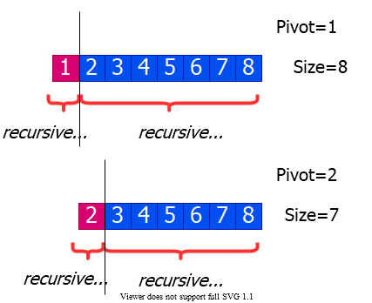

alt:“alt” height:450px center

## Worst Case Analysis of Quicksort

* **Worst case** is when the **PARTITION** algorithm always returns **imbalanced partitions** (of size $1$ and $n−1$) in every recursive call.
  + This happens when the pivot is selected to be either the min or **max** element.
  + This happens for **H-PARTITION** when the input array is already sorted or reverse sorted

$$\begin{matrix}T\left(n\right) & =T\left(1\right)+T\left(n−1\right)+Θ\left(n\right) \\ & =T\left(n−1\right)+Θ\left(n\right) \\ & =Θ\left(n2\right)\end{matrix}$$

## Worst Case Recursion Tree

$$T\left(n\right)=T\left(1\right)+T\left(n−1\right)+cn$$

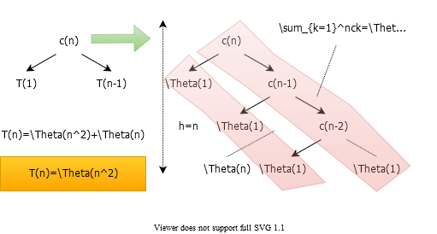

alt:“alt” height:450px center

## Best Case Analysis (for intuition only)

* If we’re extremely lucky, **H-PARTITION** splits the array evenly at every recursive call

$$\begin{matrix}T\left(n\right) & =2T\left(n/2\right)+Θ\left(n\right) \\ & =Θ\left(nlgn\right)\end{matrix}$$

*(same as merge sort)*

* Instead of splitting $0.5:0.5$, if we split $0.1:0.9$ then we need solve following equation.

$$

$$

## “Almost-Best” Case Analysis

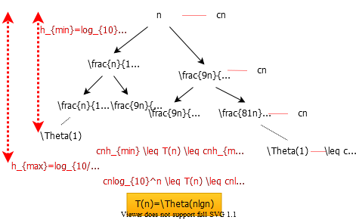

alt:“alt” height:500px center

## Balanced Partitioning (1)

* We have seen that if **H-PARTITION** always splits the array with $0.1−to−0.9$ ratio, the runtime will be $Θ\left(nlgn\right)$.
* Same is true with a split ratio of $0.01−to−0.99$, etc.
* Possible to show that if the split has always constant $\left(Θ\left(1\right)\right)$ proportionality, then the runtime will be $Θ\left(nlgn\right)$.
* In other words, for a **constant $α|\left(0<α≤0.5\right)$** :
  + $α–to–\left(1−α\right)$ proportional split yields $Θ\left(nlgn\right)$ total runtime

## Balanced Partitioning (2)

* In the rest of the analysis, assume that all input permutations are equally likely.
  + This is only to gain some intuition
  + We cannot make this assumption for average case analysis
  + We will revisit this assumption later
* Also, assume that all input elements are distinct.

## Balanced Partitioning (3)

* **Question:** What is the probability that H-PARTITION returns a split that is more balanced than $0.1−to−0.9$?

## Balanced Partitioning (4)

**Reminder:** *H-PARTITION* will place the pivot in the right partition unless the pivot is the smallest element in the arrays.

**Question:** If the pivot selected is the mth smallest value $\left(1<m≤n\right)$ in the input array, what is the size of the left region after partitioning?

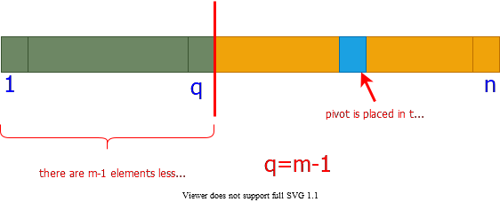

alt:“alt” height:330px center

## Balanced Partitioning (5)

* **Question:** What is the probability that the **pivot** selected is the $m^{th}$ smallest value in the array of size $n$?
  + $1/n$ (*since all input permutations are equally likely*)
* **Question:** What is the probability that the left partition returned by **H-PARTITION** has size $m$, where $1<m<n$?
  + $1/n$ (*due to the answers to the previous 2 questions*)

## Balanced Partitioning (6)

* **Question:** What is the probability that H-PARTITION returns a split that is more balanced than $0.1−to−0.9$?

$$\begin{matrix}Probability & =\sum_{q=0.1n+1}^{0.9n−1}{\frac{1}{n}} \\ & =\frac{1}{n}\left(0.9n−1−0.1n−1+1\right) \\ & =0.8−\frac{1}{n} \\ & ≈0.8\text{ for large n}\end{matrix}$$

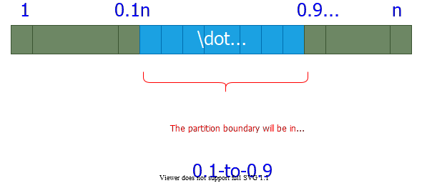

bg right:50% w:500px

## Balanced Partitioning (7)

* The probability that **H-PARTITION** yields a split that is more balanced than $0.1−to−0.9$ is $80\%$ on a random array.
* Let $P_{α>}$ be the probability that **H-PARTITION** yields a split more balanced than $α−to−\left(1−α\right)$, where $0<α≤0.5$
* Repeat the analysis to generalize the previous result

## Balanced Partitioning (8)

* **Question:** What is the probability that H-PARTITION returns a split that is more balanced than $α−to−\left(1−α\right)$?

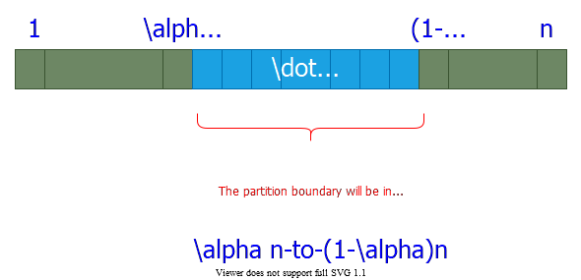

bg right:40% w:500px

$$\begin{matrix}Probability & =\sum_{q=αn+1}^{\left(1−α\right)n−1}{\frac{1}{n}} \\ & =\frac{1}{n}\left(\left(1−α\right)n−1−αn−1+1\right) \\ & =\left(1−2α\right)−\frac{1}{n} \\ & ≈\left(1−2α\right)\text{ for large n}\end{matrix}$$

## Balanced Partitioning (9)

* We found $P_{α>}=1−2α$
  + Ex: $P_{0.1>}=0.8$ and $P_{0.01>}=0.98$
* Hence, **H-PARTITION** produces a split
  + **more balanced than a**
    - $0.1−to−0.9$ split $80\%$ of the time
    - $0.01−to−0.99$ split $98\%$ of the time
  + **less balanced than a**
    - $0.1−to−0.9$ split $20\%$ of the time
    - $0.01−to−0.99$ split $2\%$ of the time

## Intuition for the Average Case (1)

* **Assumption:** All permutations are equally likely
  + Only for intuition; we’ll revisit this assumption later
* **Unlikely:** Splits always the same way at every level
* **Expectation:**
  + Some splits will be reasonably balanced
  + Some splits will be fairly unbalanced
* **Average case:** A mix of good and bad splits
  + **Good** and **bad** splits distributed randomly thru the tree

## Intuition for the Average Case (2)

* **Assume for intuition:** Good and bad splits occur in the alternate levels of the tree
  + **Good split:** Best case split
  + **Bad split:** Worst case split

## Intuition for the Average Case (3)

Compare 2-successive levels of avg case vs. 1 level of best case

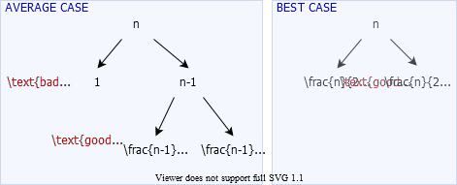

alt:“alt” h:450px center

## Intuition for the Average Case (4)

* In terms of the remaining subproblems, **two levels of avg case** is slightly better than the **single level of the best case**
* The avg case has **extra divide cost of $Θ\left(n\right)$**  at alternate levels
* The extra divide cost $Θ\left(n\right)$ of bad splits absorbed into the $Θ\left(n\right)$ of good splits.
* Running time is still $Θ\left(nlgn\right)$
  + But, slightly larger hidden constants, because the height of the recursion tree is about twice of that of best case.

## Intuition for the Average Case (5)

* Another way of looking at it:
  + Suppose we alternate lucky, unlucky, lucky, unlucky, $…$
  + We can write the recurrence as:
    - $L\left(n\right)=2U\left(n/2\right)+Θ\left(n\right)$ lucky split (best)
    - $U\left(n\right)=L\left(n−1\right)+Θ\left(n\right)$ unlucky split (worst)
  + Solving:
$$\begin{matrix}L\left(n\right) & =2\left(L\left(n/2−1\right)+Θ\left(n/2\right)\right)+Θ\left(n\right) \\ & =2L\left(n/2−1\right)+Θ\left(n\right) \\ & =Θ\left(nlgn\right)\end{matrix}$$

* How can we make sure we are usually lucky for all inputs?

## Summary: Quicksort Runtime Analysis (1)

* **Worst case:** Unbalanced split at every recursive call
$$\begin{matrix}T\left(n\right) & =T\left(1\right)+T\left(n−1\right)+Θ\left(n\right) \\ T\left(n\right) & =Θ\left(n2\right)\end{matrix}$$

* **Best case:** Balanced split at every recursive call (*extremely lucky*)

$$\begin{matrix}T\left(n\right) & =2T\left(n/2\right)+Θ\left(n\right) \\ T\left(n\right) & =Θ\left(nlgn\right)\end{matrix}$$

## Summary: Quicksort Runtime Analysis (2)

* **Almost-best case:** Almost-balanced split at every recursive call

$$\begin{matrix}T\left(n\right) & =T\left(n/10\right)+T\left(9n/10\right)+Θ\left(n\right) \\ \text{or }T\left(n\right) & =T\left(n/100\right)+T\left(99n/100\right)+Θ\left(n\right) \\ \text{or }T\left(n\right) & =T\left(αn\right)+T(\left(1−αn\right)+Θ\left(n\right)\end{matrix}$$

for any constant $α,0<α≤0.5$

## Summary: Quicksort Runtime Analysis (3)

* For a random input array, the probability of having a split
  + more balanced than $0.1–to–0.9:80\%$
  + more balanced than $0.01–to–0.99:98\%$
  + more balanced than $α–to–\left(1−α\right):1–2α$
* for any constant $α,0<α≤0.5$

## Summary: Quicksort Runtime Analysis (4)

* **Avg case intuition:** Different splits expected at different levels
  + some balanced (good), some unbalanced (bad)
* **Avg case intuition:** Assume the good and bad splits alternate
  + i.e. good split -> bad split -> good split -> …
 $T\left(n\right)=Θ\left(nlgn\right)$

   - (informal analysis for intuition)

## Randomized Quicksort

* In the avg-case analysis, we assumed that **all permutations** of the input array are **equally likely.**
  + But, this assumption **does not always hold**
  + e.g. What if **all** the input arrays are **reverse sorted**?
    - **Always worst-case behavior**
* Ideally, the avg-case runtime should be **independent of the input permutation**.
* **Randomness should be within the algorithm**, not based on the distribution of the inputs.
  + i.e. The avg case should hold for all possible inputs

## Randomized Algorithms (1)

* Alternative to assuming a uniform distribution:
  + **Impose a uniform distribution**
  + e.g. Choose a random pivot rather than the first element
* Typically useful when:
  + there are many ways that an algorithm can proceed
  + but, it’s **difficult** to determine a way that is **always guaranteed to be good**.
  + If there are **many good alternatives**; simply **choose one randomly**.

## Randomized Algorithms (1)

* Ideally:
  + Runtime should be **independent of the specific inputs**
  + No specific input should cause worst-case behavior
  + Worst-case should be determined only by output of a random number generator.

## Randomized Quicksort (1)

* Using Hoare’s partitioning algorithm:

R-QUICKSORT(A, p, r)  
 if p < r then  
 q = R-PARTITION(A, p, r)  
 R-QUICKSORT(A, p, q)  
 R-QUICKSORT(A, q+1, r)

R-PARTITION(A, p, r)  
 s = RANDOM(p, r)  
 exchange A[p] with A[s]  
 return H-PARTITION(A, p, r)

* Alternatively, permuting the whole array would also work
  + but, would be more difficult to analyze

## Randomized Quicksort (2)

* Using Lomuto’s partitioning algorithm:

R-QUICKSORT(A, p, r)  
 if p < r then  
 q = R-PARTITION(A, p, r)  
 R-QUICKSORT(A, p, q-1)  
 R-QUICKSORT(A, q+1, r)

R-PARTITION(A, p, r)  
 s = RANDOM(p, r)  
 exchange A[r] with A[s]  
 return L-PARTITION(A, p, r)

* Alternatively, permuting the whole array would also work
  + but, would be more difficult to analyze

## Notations for Formal Analysis

* Assume all elements in $A\left[p…r\right]$ are distinct
  + Let $n=r–p+1$
* Let $rank\left(x\right)=\left|A\left[i\right]:p≤i≤r\text{ and }A\left[i\right]≤x\right|$
* i.e. $rank\left(x\right)$  is the number of array elements with value less than or equal to
  + - i.e. it is the $3^{rd}$ smallest element in the array

## Formal Analysis for Average Case

* The following analysis will be for **Quicksort** using **Hoare’s** partitioning algorithm.
* **Reminder:** The **pivot** is selected **randomly** and exchanged with $A\left[p\right]$ before calling **H-PARTITION**
* Let $x$ be the **random pivot** chosen.
* What is the probability that $rank\left(x\right)=i$ for $i=1,2,…n$?

$P\left(rank\left(x\right)=i\right)=1/n$

## Various Outcomes of H-PARTITION (1)

* Assume that $rank\left(x\right)=1$
  + i.e. the **random pivot** chosen is the **smallest** element
  + What will be the **size of the left partition $\left(\left|L\right|\right)$** ?
  + **Reminder:** Only the elements less than or equal to $x$ will be in the left partition.

$A=\{\overset{p=x=pivot}{\overbrace{2}}\underset{⇒\left|L\right|=1}{\underset{⏟}{,}}9,7,6,8,5,\overset{r}{\overbrace{4}}\}$

$p=2,r=4$ $pivot=x=2$

**TODO: convert to image…S6_P9**

## Various Outcomes of H-PARTITION (2)

* Assume that $rank\left(x\right)>1$
  + i.e. the random pivot chosen is not the smallest element
  + What will be the size of the left partition $\left(\left|L\right|\right)$?
  + **Reminder:** Only the elements less than or equal to $x$ will be in the left partition.
  + **Reminder:** The pivot will stay in the right region after **H-PARTITION** if $rank\left(x\right)>1$

$A=\{\overset{p}{\overbrace{2}},4\underset{⇒\left|L\right|=rank\left(x\right)−1}{\underset{⏟}{,}}7,6,8,\overset{pivot}{\overbrace{5,}}\overset{r}{\overbrace{9}}\}$

$p=2,r=4$ $pivot=x=5$

**TODO: convert to image…S6_P10**

## Various Outcomes of H-PARTITION - Summary (1)

$x:pivot$

$\left|L\right|:\text{size of left region}$

$P\left(rank\left(x\right)=i\right)=1/n\text{ for }1≤i≤n$

$\text{if }rank\left(x\right)=1\text{ then }\left|L\right|=1$

$\text{if }rank\left(x\right)>1\text{ then }\left|L\right|=rank\left(x\right)−1$

$P\left(\left|L\right|=1\right)=P\left(rank\left(x\right)=1\right)+P\left(rank\left(x\right)=2\right)$

$P\left(\left|L\right|=1\right)=2/n$

$P\left(\left|L\right|=i\right)=P\left(rank\left(x\right)=i+1\right)\text{ for }1<i<n$

$P\left(\left|L\right|=i\right)=1/n\text{ for }1<i<n$

## Various Outcomes of H-PARTITION - Summary (2)

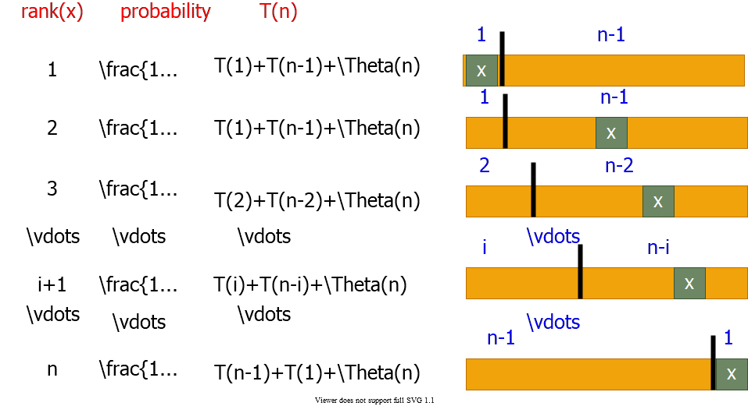

alt:“alt” h:450px center

## Average - Case Analysis: Recurrence (1)

$x=pivot$

$$\begin{matrix}T\left(n\right) & =\frac{1}{n}\left(T\left(1\right)+t\left(n−1\right)\right) & rank:1 \\ & +\frac{1}{n}\left(T\left(1\right)+t\left(n−1\right)\right) & rank:2 \\ & +\frac{1}{n}\left(T\left(2\right)+t\left(n−2\right)\right) & rank:3 \\ & ⋮ & ⋮ \\ & +\frac{1}{n}\left(T\left(i\right)+t\left(n−i\right)\right) & rank:i+1 \\ & ⋮ & ⋮ \\ & +\frac{1}{n}\left(T\left(n−1\right)+t\left(1\right)\right) & rank:n \\ & +Θ\left(n\right)\end{matrix}$$

## Average - Case Analysis: Recurrence (2)

$$\begin{matrix}T\left(n\right) & =\frac{1}{n}\sum_{q=1}^{n−1}{\left(T\left(q\right)+T\left(n−q\right)\right)}+\frac{1}{n}\left(T\left(1\right)+T\left(n−1\right)\right)+Θ\left(n\right) \\ & \text{Note: }\frac{1}{n}\left(T\left(1\right)+T\left(n−1\right)\right)=\frac{1}{n}\left(Θ\left(1\right)+O\left(n^{2}\right)\right)=O\left(n\right) \\ T\left(n\right) & =\frac{1}{n}\sum_{q=1}^{n−1}{\left(T\left(q\right)+T\left(n−q\right)\right)}+Θ\left(n\right)\end{matrix}$$

for $k=1,2,…,n−1$ each term $T\left(k\right)$ appears twice once for $q=k$ and once for $q=n−k$

$$T\left(n\right)=\frac{2}{n}\sum_{k=1}^{n−1}{T}\left(k\right)+Θ\left(n\right)$$

## Average - Case Analysis -Solving Recurrence: Substitution

* Guess: $T\left(n\right)=O\left(nlgn\right)$
* $T\left(k\right)≤aklgk$ for $k<n$, for some constant $a>0$
$$\begin{matrix}T\left(n\right) & =\frac{2}{n}\sum_{k=1}^{n−1}{T}\left(k\right)+Θ\left(n\right) \\ & ≤\frac{2}{n}\sum_{k=1}^{n−1}{a}klgk+Θ\left(n\right) \\ & ≤\frac{2a}{n}\sum_{k=1}^{n−1}{k}lgk+Θ\left(n\right)\end{matrix}$$

* Need a tight bound for $∑klgk$

## Tight bound for $∑klgk$ (1)

* Bounding the terms
 $\sum_{k=1}^{n−1}{k}lgk≤\sum_{k=1}^{n−1}{n}lgn=n\left(n−1\right)lgn≤n^{2}lgn$

 + This bound **is not strong** enough because
 $T\left(n\right)≤\frac{2a}{n}n^{2}lgn+Θ\left(n\right)$

 $=2anlgn+Θ\left(n\right)$ $⇒$ + couldn’t prove $T\left(n\right)≤anlgn$

## Tight bound for $∑klgk$ (2)

* **Splitting summations:** ignore ceilings for simplicity
 $$\sum_{k=1}^{n−1}{k}lgk≤\sum_{k=1}^{n/2−1}{k}lgk+\sum_{k=n/2}^{n−1}{k}lgk$$

 + **First summation**: $lgk<lg\left(n/2\right)=lgn−1$
  + **Second summation**: $lgk<lgn$

## Splitting: $\sum_{k=1}^{n−1}{k}lgk≤\sum_{k=1}^{n/2−1}{k}lgk+\sum_{k=n/2}^{n−1}{k}lgk$ (3)

$$\begin{matrix} & \sum_{k=1}^{n−1}{k}lgk≤\left(lg\left(n−1\right)\right)\sum_{k=1}^{n/2−1}{k}+lgn\sum_{k=n/2}^{n−1}{k} \\ & =lgn\sum_{k=1}^{n−1}{k}−\sum_{k=1}^{n/2−1}{k} \\ & =\frac{1}{2}n\left(n−1\right)lgn−\frac{1}{2}\frac{n}{2}\left(\frac{n}{2}−1\right) \\ & =\frac{1}{2}n^{2}lgn−\frac{1}{8}n^{2}−\frac{1}{2}n\left(lgn−1/2\right)\end{matrix}$$

$$\begin{matrix} & \sum_{k=1}^{n−1}{k}lgk≤\frac{1}{2}n^{2}lgn−\frac{1}{8}n^{2} for lgn≥1/2⇒n≥\sqrt{2}\end{matrix}$$

## Substituting: - $\sum_{k=1}^{n−1}{k}lgk≤\frac{1}{2}n^{2}lgn−\frac{1}{8}n^{2}$ (4)

$$\begin{matrix}T\left(n\right) & ≤\frac{2a}{n}\sum_{k=1}^{n−1}{k}lgk+Θ\left(n\right) \\ & ≤\frac{2a}{n}\left(\frac{1}{2}n^{2}lgn−\frac{1}{8}n^{2}\right)+Θ\left(n\right) \\ & =anlgn−\left(\frac{a}{4}n−Θ\left(n\right)\right)\end{matrix}$$

* We can choose a large enough so that $\frac{a}{4}n≥Θ\left(n\right)$

$$\begin{matrix}T\left(n\right) & ≤anlgn \\ T\left(n\right) & =O\left(nlgn\right)\end{matrix}$$

Q.E.D.

## Medians and Order Statistics

* **ith order statistic**: $i^{th}$ smallest element of a set of $n$ elements
* **minimum:** *first* order statistic
* **maximum: $n^{th}$** order statistic
* **median:** “halfway point” of the set

$$\begin{matrix}i & =⌊\frac{\left(n+1\right)}{2}⌋ \\ \text{ or } \\ i & =⌈\frac{\left(n+1\right)}{2}⌉\end{matrix}$$

## Selection Problem

* **Selection problem:** Select the $i^{th}$ smallest of $n$ elements
* **Naïve algorithm:** Sort the input array $A$; then return
  + - *using e.g. merge sort (but not quicksort)*
* Can we do any better?

## Selection in Expected Linear Time

* Randomized algorithm using divide and conquer
* Similar to randomized quicksort
  + **Like quicksort:** Partitions input array recursively
  + **Unlike quicksort:** Makes a single recursive call
    - **Reminder:** *Quicksort makes two recursive calls*
* Expected runtime: $Θ\left(n\right)$
  + **Reminder:** *Expected runtime of quicksort: $Θ\left(nlgn\right)$*

## Selection in Expected Linear Time: Example 1

* Select the $2^{nd}$ smallest element:
$$\begin{matrix}A & =\{6,10,13,5,8,3,2,11\} \\ i & =2\end{matrix}$$

* Partition the input array:
$$\begin{matrix}A & =\{\underset{\text{left subarray}}{\underset{⏟}{2,3,5,}}\underset{\text{right subarray}}{\underset{⏟}{13,8,10,6,11}}\}\end{matrix}$$

* make a recursive call to select the $2^{nd}$ **smallest** element in **left subarray**

## Selection in Expected Linear Time: Example 2

* Select the $7^{th}$ smallest element:
$$\begin{matrix}A & =\{6,10,13,5,8,3,2,11\} \\ i & =7\end{matrix}$$

* Partition the input array:
$$\begin{matrix}A & =\{\underset{\text{left subarray}}{\underset{⏟}{2,3,5,}}\underset{\text{right subarray}}{\underset{⏟}{13,8,10,6,11}}\}\end{matrix}$$

* make a recursive call to select the $4^{th}$ **smallest** element in **right subarray**

## Selection in Expected Linear Time (1)

R-SELECT(A,p,r,i)  
 if p == r then   
 return A[p];  
 q = R-PARTITION(A, p, r)  
 k = q–p+1;  
 if i <= k then   
 return R-SELECT(A, p, q, i);  
 else  
 return R-SELECT(A, q+1, r, i-k);

$$\begin{matrix}A & =\{\underset{p}{\underset{⏟}{|}}…≤x\text{(k smallest elements)}…\underset{q}{\underset{⏟}{|}}…≥x…\underset{r}{\underset{⏟}{|}}\} \\ x & =pivot\end{matrix}$$

## Selection in Expected Linear Time (2)

$$\begin{matrix}A & =\{\overset{p}{\overbrace{|}}\underset{L}{\underset{⏟}{…≤x…}}\overset{q}{\overbrace{|}}\underset{R}{\underset{⏟}{…≥x…}}\overset{r}{\overbrace{|}}\} \\ x & =pivot\end{matrix}$$

* All elements in $L≤$ all elements in $R$
* $L$ contains:
  + $\left|L\right|=q–p+1$ $=$ k smallest elements of $A\left[p...r\right]$
  + if $i≤\left|L\right|=k$ then
    - **search $L$** recursively for its $i^{th}$ smallest element
  + else
    - **search $R$** recursively for its ${\left(i−k\right)}^{th}$ smallest element

## Runtime Analysis (1)

* **Worst case:**
  + Imbalanced partitioning at every level and the recursive call always to the larger partition

$$\begin{matrix} & =\{1,\underset{\text{recursive call}}{\underset{⏟}{2,3,4,5,6,7,8}}\} & i & =8 \\ & =\{2,\underset{\text{recursive call}}{\underset{⏟}{3,4,5,6,7,8}}\} & i & =7\end{matrix}$$

## Runtime Analysis (2)

* **Worst case:** Worse than the naïve method (based on sorting)
$$\begin{matrix}T\left(n\right) & =T\left(n−1\right)+Θ\left(n\right) \\ T\left(n\right) & =Θ\left(n^{2}\right)\end{matrix}$$

* **Best case:** Balanced partitioning at every recursive level
$$\begin{matrix}T\left(n\right) & =T\left(n/2\right)+Θ\left(n\right) \\ T\left(n\right) & =Θ\left(n\right)\end{matrix}$$

* **Avg case:** Expected runtime – need analysis T.B.D.

## Reminder: Various Outcomes of H-PARTITION

$x:pivot$

$\left|L\right|:\text{size of left region}$

$P\left(rank\left(x\right)=i\right)=1/n\text{ for }1≤i≤n$

$\text{if }rank\left(x\right)=1\text{ then }\left|L\right|=1$

$\text{if }rank\left(x\right)>1\text{ then }\left|L\right|=rank\left(x\right)−1$

$P\left(\left|L\right|=1\right)=P\left(rank\left(x\right)=1\right)+P\left(rank\left(x\right)=2\right)$

$P\left(\left|L\right|=1\right)=2/n$

$P\left(\left|L\right|=i\right)=P\left(rank\left(x\right)=i+1\right)\text{ for }1<i<n$

$P\left(\left|L\right|=i\right)=1/n\text{ for }1<i<n$

## Average Case Analysis of Randomized Select

* To compute the **upper bound** for the **avg case**, assume that the $i^{th}$ element always falls into the **larger partition**.
$$\begin{matrix}A & =\{\overset{p}{\overbrace{|}}\underset{LeftPartition}{\underset{⏟}{…≤x…}}\overset{q}{\overbrace{|}}\underset{RightPartition}{\underset{⏟}{…≥x…}}\overset{r}{\overbrace{|}}\} \\ x & =pivot\end{matrix}$$

* We will analyze the case where the recursive call is always made to the larger partition
  + *This will give us an upper bound for the avg case*

## Various Outcomes of H-PARTITION

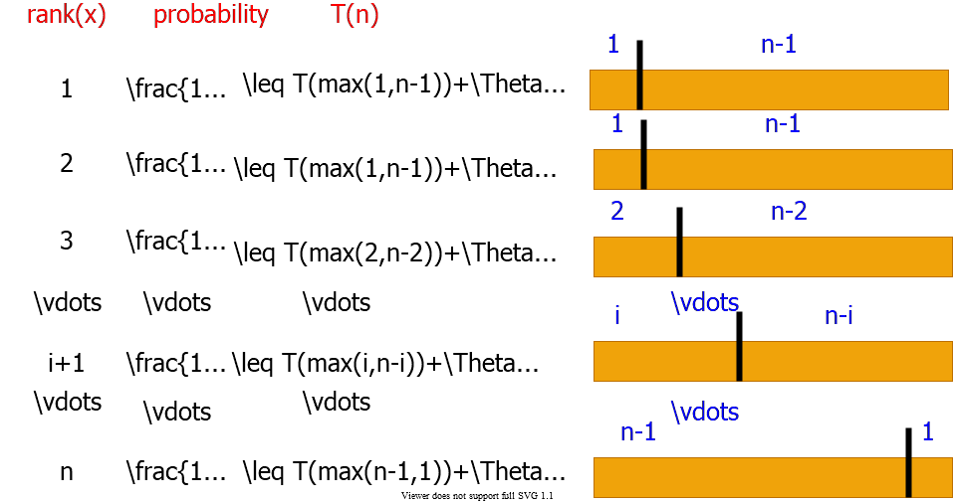

alt:“alt” h:450px center

## Average-Case Analysis of Randomized Select (1)

$$\text{Recall:}P\left(\left|L\right|=i\right)=\left\{\begin{matrix}2/n & \text{for }i=1 \\ 1/n & \text{for }i=2,3,…,n−1\end{matrix}\right.$$

**Upper bound:** Assume $i^{th}$ element always falls into the larger part.

$$\begin{matrix}T\left(n\right) & ≤\frac{1}{n}T\left(max\left(1,n−1\right)\right)+\frac{1}{n}\sum_{q=1}^{n−1}{T}\left(max\left(q,n−q\right)\right)+O\left(n\right) \\ Note: & \frac{1}{n}T\left(max\left(1,n−1\right)\right)=\frac{1}{n}T\left(n−1\right)=\frac{1}{n}O\left(n^{2}\right)=O\left(n\right) \\ ∴\text{(3 dot mean therefore) } & T\left(n\right)≤\frac{1}{n}\sum_{q=1}^{n−1}{T}\left(max\left(q,n−q\right)\right)+O\left(n\right)\end{matrix}$$

## Average-Case Analysis of Randomized Select (2)

$$\begin{matrix}∴T\left(n\right)≤\frac{1}{n}\sum_{q=1}^{n−1}{T}\left(max\left(q,n−q\right)\right)+O\left(n\right)\end{matrix}$$

$$max\left(q,n–q\right)=\left\{\begin{matrix}q & \text{ if }q≥⌈n/2⌉ \\ n−q & \text{ if }q<⌈n/2⌉\end{matrix}\right.$$

* $n$ is odd: $T\left(k\right)$ appears twice for $k=⌈n/2⌉+1,⌈n/2⌉+2,…,n–1$
* $n$ is even: $T\left(⌈n/2⌉\right)$ appears once $T\left(k\right)$ appears twice for $k=⌈n/2⌉+1,⌈n/2⌉+2,…,n–1$

## Average-Case Analysis of Randomized Select (3)

* Hence, in both cases:

$$\begin{matrix}\sum_{q=1}^{n−1}{T}\left(max\left(q,n−q\right)\right)+O\left(n\right) & ≤2\sum_{q=⌈n/2⌉}^{n−1}{T}\left(q\right)+O\left(n\right) \\ ∴T\left(n\right) & ≤\frac{2}{n}\sum_{q=⌈n/2⌉}^{n−1}{T}\left(q\right)+O\left(n\right)\end{matrix}$$

## Average-Case Analysis of Randomized Select (4)

$$\begin{matrix}T\left(n\right) & ≤\frac{2}{n}\sum_{q=⌈n/2⌉}^{n−1}{T}\left(q\right)+O\left(n\right)\end{matrix}$$

* By substitution guess $T\left(n\right)=O\left(n\right)$
* Inductive hypothesis: $T\left(k\right)≤ck,∀k<n$

$$\begin{matrix}T\left(n\right) & ≤\frac{2}{n}\sum_{q=⌈n/2⌉}^{n−1}{c}k+O\left(n\right) \\ & =\frac{2c}{n}(\sum_{k=1}^{n−1}{k}−\sum_{k=1}^{⌈n/2⌉−1}{k})+O\left(n\right) \\ & =\frac{2c}{n}(\frac{1}{2}n\left(n−1\right)−\frac{1}{2}⌈\frac{n}{2}⌉(\frac{n}{2}−1))+O\left(n\right)\end{matrix}$$

## Average-Case Analysis of Randomized Select (5)

$$\begin{matrix}T\left(n\right) & ≤\frac{2c}{n}(\frac{1}{2}n\left(n−1\right)−\frac{1}{2}⌈\frac{n}{2}⌉(\frac{n}{2}−1))+O\left(n\right) \\ & ≤c\left(n−1\right)−\frac{c}{4}n+\frac{c}{2}+O\left(n\right) \\ & =cn−\frac{c}{4}n−\frac{c}{2}+O\left(n\right) \\ & =cn−((\frac{c}{4}n+\frac{c}{2})+O\left(n\right)) \\ & ≤cn\end{matrix}$$

* since we can choose c large enough so that $\left(cn/4+c/2\right)$ dominates $O\left(n\right)$

## Summary of Randomized Order-Statistic Selection

* Works fast: linear expected time
* Excellent algorithm in practise
* But, the worst case is very bad: $Θ\left(n^{2}\right)$
* **Blum, Floyd, Pratt, Rivest & Tarjan[1973]** algorithms are runs in **linear time** in the **worst case**.
* Generate a **good pivot** recursively

## Selection in Worst Case Linear Time

//return i-th element in set S with n elements  
SELECT(S, n, i)   
  
 if n <= 5 then  
  
 SORT S and return the i-th element  
  
 DIVIDE S into ceil(n/5) groups  
 //first ceil(n/5) groups are of size 5, last group is of size n mod 5  
  
 FIND median set M={m , …, m_ceil(n/5)}  
 // m_j : median of j-th group  
  
 x = SELECT(M,ceil(n/5),floor((ceil(n/5)+1)/2))  
  
 PARTITION set S around the pivot x into L and R  
  
 if i <= |L| then  
 return SELECT(L, |L|, i)  
 else  
 return SELECT(R, n–|L|, i–|L|)

## Selection in Worst Case Linear Time - Example (1)

* **Input:** Array $S$ and index $i$
* **Output:** The $i^{th}$ smallest value

$$\begin{matrix}25 & 9 & 16 & 8 & 11 & 27 & 39 & 42 & 15 & 632 & 14 & 36 & 20 & 33 & 22 & 31 & 4 & 17 & 3 & 30 & 41 \\ 2 & 13 & 19 & 7 & 21 & 10 & 34 & 1 & 37 & 23 & 40 & 5 & 29 & 18 & 24 & 12 & 38 & 28 & 26 & 35 & 43\end{matrix}$$

## Selection in Worst Case Linear Time - Example (2)

**Step 1:** Divide the input array into groups of size $5$

$$\overset{\text{group size}=5}{\overbrace{\begin{matrix}25 & 9 & 16 & 8 & 11 \\ 27 & 39 & 42 & 15 & 6 \\ 32 & 14 & 36 & 20 & 33 \\ 22 & 31 & 4 & 17 & 3 \\ 30 & 41 & 2 & 13 & 19 \\ 7 & 21 & 10 & 34 & 1 \\ 37 & 23 & 40 & 5 & 29 \\ 18 & 24 & 12 & 38 & 28 \\ 26 & 35 & 43\end{matrix}}}$$

## Selection in Worst Case Linear Time - Example (3)

**Step 2:** Compute the median of each group ($Θ\left(n\right)$)

$$\begin{matrix}25 & 16 & \overset{Medians}{\overbrace{11}} & 8 & 9 \\ 39 & 42 & 27 & 6 & 15 \\ 36 & 33 & 32 & 20 & 14 \\ 22 & 31 & 17 & 3 & 4 \\ 41 & 30 & 19 & 13 & 2 \\ 21 & 34 & 10 & 1 & 7 \\ 37 & 40 & 29 & 23 & 5 \\ 38 & 28 & 24 & 12 & 18 \\ & 26 & 35 & 43\end{matrix}$$

* Let $M$ be the set of the medians computed:

$M=\{11,27,32,17,19,10,29,24,35\}$

## Selection in Worst Case Linear Time - Example (4)

**Step 3:** Compute the median of the median group $M$

$x←SELECT\left(M,\left|M\right|,⌊\left(\left|M\right|+1\right)/2⌋\right)$ where $\left|M\right|=⌈n/5⌉$

* Let $M$ be the set of the medians computed:
$M=\{11,27,32,17,19,10,29,\overset{Median}{\overbrace{24}},35\}$

$Median=24$

* The runtime of the recursive call: $T\left(\left|M\right|\right)=T\left(⌈n/5⌉\right)$

## Selection in Worst Case Linear Time - Example (5)

**Step 4:** Partition the input array $S$ around the median-of-medians $x$

$$\begin{matrix}25 & 9 & 16 & 8 & 11 & 27 & 39 & 42 & 15 & 632 & 14 & 36 & 20 & 33 & 22 & 31 & 4 & 17 & 3 & 30 & 41 \\ 2 & 13 & 19 & 7 & 21 & 10 & 34 & 1 & 37 & 23 & 40 & 5 & 29 & 18 & 24 & 12 & 38 & 28 & 26 & 35 & 43\end{matrix}$$

Partition $S$ around $x=24$

**Claim:** Partitioning around x is guaranteed to be **well-balanced.**

## Selection in Worst Case Linear Time - Example (6)

* $M$: Median, $M^{*}$: Median of Medians
$$\begin{matrix}41 & 30 & \overset{M}{\overbrace{19}} & 13 & 2 \\ 21 & 34 & 10 & 1 & 7 \\ 22 & 31 & 17 & 3 & 4 \\ 25 & 16 & 11 & 8 & 9 \\ 38 & 28 & \overset{M^{*}}{\overbrace{24}} & 12 & 18 \\ 36 & 33 & 32 & 20 & 14 \\ 37 & 40 & 29 & 23 & 5 \\ 39 & 42 & 27 & 6 & 15 \\ & 26 & 35 & 43\end{matrix}$$

* About half of the medians greater than $x=24$ (about $n/10$)

## Selection in Worst Case Linear Time - Example (7)

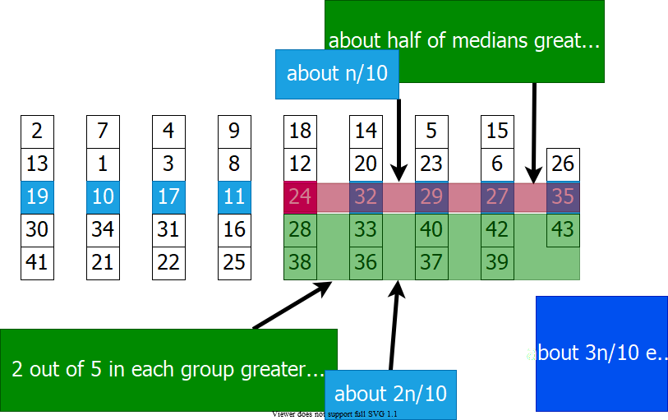

alt:“alt” h:500px center

## Selection in Worst Case Linear Time - Example (8)

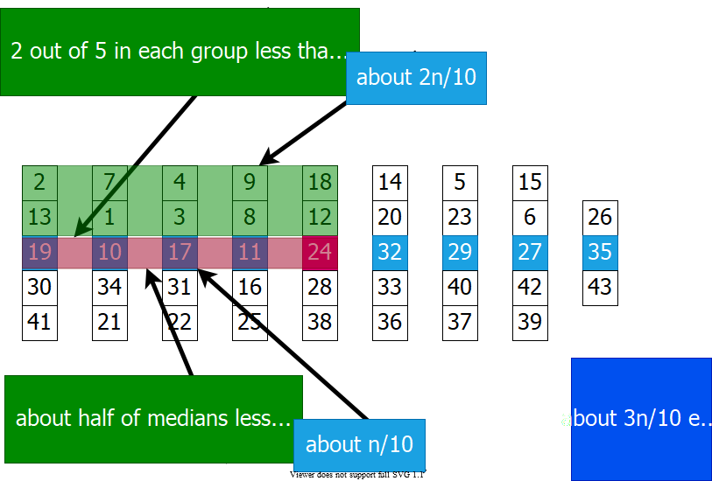

alt:“alt” h:500px center

## Selection in Worst Case Linear Time - Example (9)

$$S=\begin{matrix}\{25 & 9 & 16 & 8 & 11 & 27 & 39 & 42 & 15 & 632 & 14 & 36 & 20 & 33 & 22 & 31 & 4 & 17 & 3 & 30 & 41 \\ 2 & 13 & 19 & 7 & 21 & 10 & 34 & 1 & 37 & 23 & 40 & 5 & 29 & 18 & 24 & 12 & 38 & 28 & 26 & 35 & 43\}\end{matrix}$$

* Partitioning $S$ around $x=24$ will lead to partitions of sizes $∼3n/10$ and $∼7n/10$ in the **worst case**.

**Step 5:** Make a recursive call to one of the partitions

if i <= |L| then   
 return SELECT(L,|L|,i)  
else   
 return SELECT(R,n-|L|,i-|L|)

## Selection in Worst Case Linear Time

//return i-th element in set S with n elements  
SELECT(S, n, i)   
  
 if n <= 5 then  
  
 SORT S and return the i-th element  
  
 DIVIDE S into ceil(n/5) groups  
 //first ceil(n/5) groups are of size 5, last group is of size n mod 5  
  
 FIND median set M={m , …, m_ceil(n/5)}  
 // m_j : median of j-th group  
  
 x = SELECT(M,ceil(n/5),floor((ceil(n/5)+1)/2))  
  
 PARTITION set S around the pivot x into L and R  
  
 if i <= |L| then  
 return SELECT(L, |L|, i)  
 else  
 return SELECT(R, n–|L|, i–|L|)

## Choosing the Pivot (1)

1. Divide S into groups of size 5



alt:“alt” h:450px center

## Choosing the Pivot (2)

* Divide S into groups of size 5
* Find the median of each group

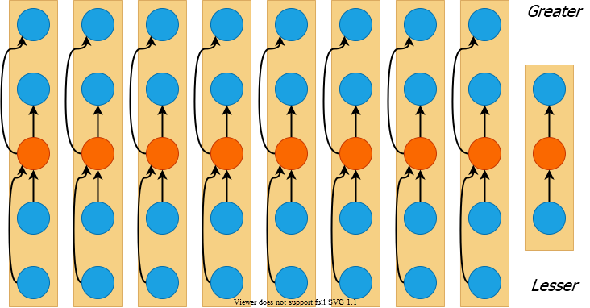

alt:“alt” h:450px center

## Choosing the Pivot (3)

* Divide S into groups of size 5
* Find the median of each group
* Recursively select the median x of the medians

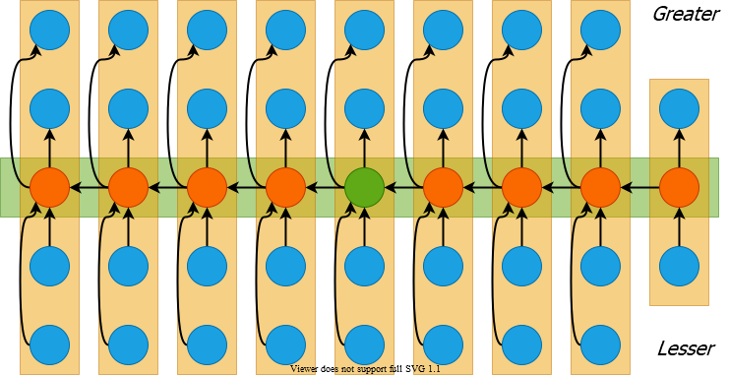

alt:“alt” h:450px center

## Choosing the Pivot (4)

* At least half of the medians $≥x$
* Thus $m=⌈⌈n/5⌉/2⌉$ groups contribute 3 elements to R except possibly the last group and the group that contains $x$, $\left|R\right|≥3\left(m–2\right)≥\frac{3n}{10}–6$

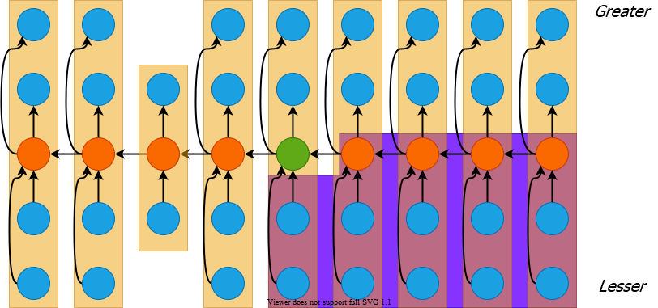

alt:“alt” h:400px center

## Choosing the Pivot (5)

* Similarly $\left|L\right|≥\frac{3n}{10}–6$
* Therefore, **SELECT** is recursively called on at most $n−\left(\frac{3n}{10}−6\right)=\frac{7n}{10}+6$ elements

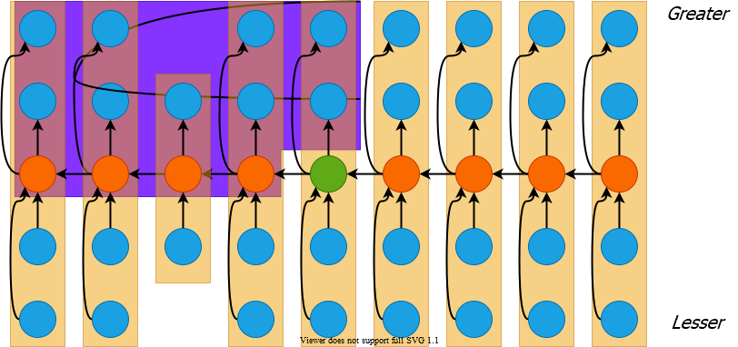

alt:“alt” h:400px center

## Selection in Worst Case Linear Time (1)

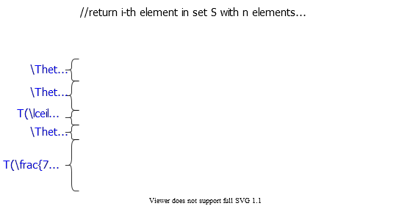

alt:“alt” h:500px center

## Selection in Worst Case Linear Time (2)

* Thus recurrence becomes
$T\left(n\right)≤T(⌈\frac{n}{5}⌉)+T(\frac{7n}{10}+6)+Θ\left(n\right)$

* Guess $T\left(n\right)=O\left(n\right)$ and prove by induction
* Inductive step:
$$\begin{matrix}T\left(n\right) & ≤c⌈n/5⌉+c\left(7n/10+6\right)+Θ\left(n\right) \\ & ≤cn/5+c+7cn/10+6c+Θ\left(n\right) \\ & =9cn/10+7c+Θ\left(n\right) \\ & =cn−\left[c\left(n/10−7\right)−Θ\left(n\right)\right]≤cn & \text{( for large c)}\end{matrix}$$

* Work at each level of recursion is a constant factor $\left(9/10\right)$ smaller

## References

* [Introduction to Algorithms, Third Edition | The MIT Press](https://mitpress.mit.edu/books/introduction-algorithms-third-edition)
* [Bilkent CS473 Course Notes (new)](http://nabil.abubaker.bilkent.edu.tr/473/)
* [Bilkent CS473 Course Notes (old)](http://cs.bilkent.edu.tr/~ugur/teaching/cs473/)
* [Insertion Sort - GeeksforGeeks](https://www.geeksforgeeks.org/insertion-sort/)
* [NIST Dictionary of Algorithms and Data Structures](https://xlinux.nist.gov/dads/)
* [NIST - Dictionary of Algorithms and Data Structures](https://xlinux.nist.gov/dads/)
* [NIST - big-O notation](https://xlinux.nist.gov/dads/HTML/bigOnotation.html)
* [NIST - big-Omega notation](https://xlinux.nist.gov/dads/HTML/omegaCapital.html)
* [Discovering novel algorithms with AlphaTensor](https://www.deepmind.com/blog/discovering-novel-algorithms-with-alphatensor)

$−End−Of−Week−3−Course−Module−$